🧪 🖥️ BASIC SHELL SCRIPTING LAB
🎯 Goal
Create a script that:
- Greets user
- Takes input
- Checks files
- Uses conditions
- Automates small tasks

⚙️ Step 1: Create your first script
nano firstscript.sh

✍️ Step 2: Add this script
#!/bin/bash
echo "🚀 Welcome to Shell Scripting Lab"
echo "Enter your name:"
read name
echo "Hello $name 😄"
echo "Today we learn automation!"
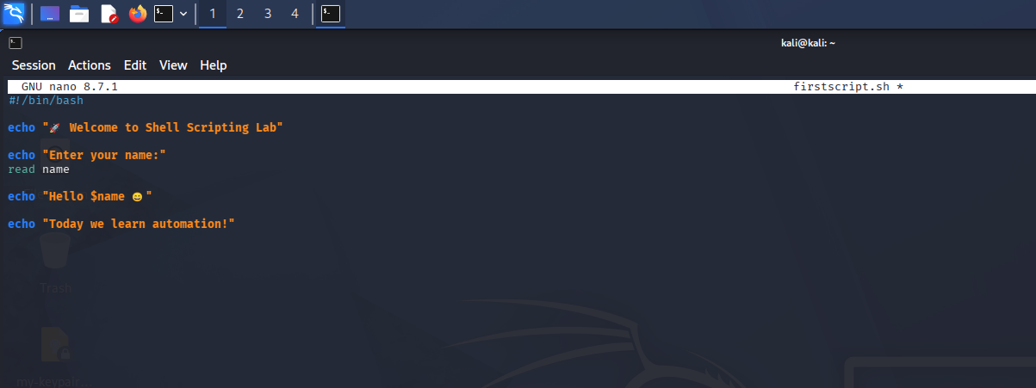

🧠 Explanation
Line | Meaning
#!/bin/bash | Use bash shell
echo | Print message
read name | Take input
$name | Variable value

🔐 Step 3: Give execute permission
chmod +x firstscript.sh
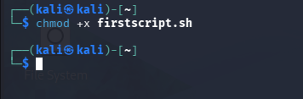

▶️ Step 4: Run script
./firstscript.sh

🎯 Expected Output
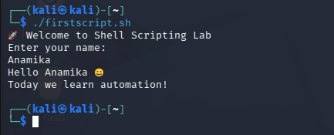

🔥 Step 5: Add condition (if/else)
Edit script:
nano firstscript.sh
Add:
#!/bin/bash
echo "Enter your age:"
read age
if [ $age -ge 18 ]
then
echo "✅ You can work in production 😎"
else
echo "📚 Keep learning and growing!"
fi
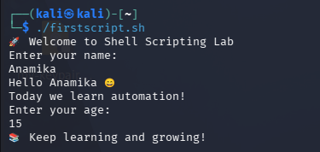
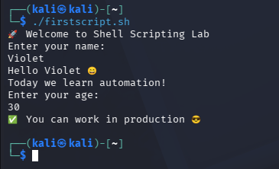

🧠 What this teaches
Part | Meaning
if | Condition
-ge | Greater than or equal
then | Run this block
else | Otherwise

🔁 Step 6: Add loop
Create new script:
nano loop.sh
Paste:
#!/bin/bash
for i in 1 2 3 4 5
do
echo "🔥 DevOps Practice Day $i"
done
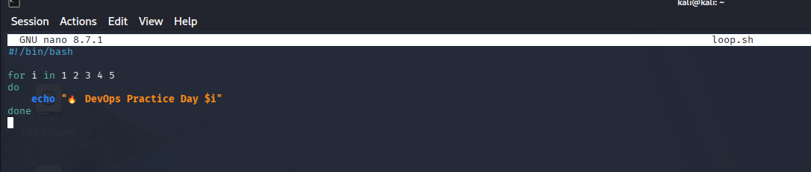
Run:
chmod +x loop.sh
./loop.sh
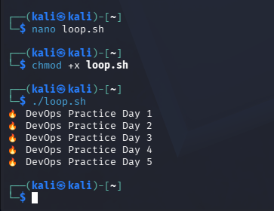

📂 Step 7: Check if file exists
nano filecheck.sh
Paste:
#!/bin/bash
echo "Enter file name:"
read file
if [ -f "$file" ]
then
echo "✅ File exists"
else
echo "❌ File not found"
fi
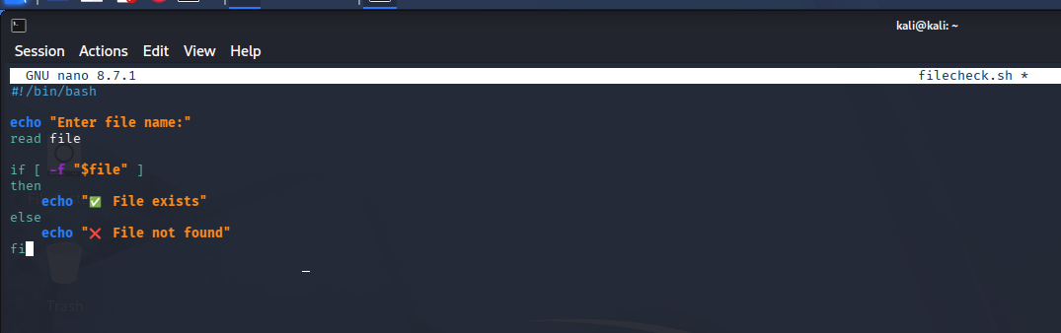

Expected Output :
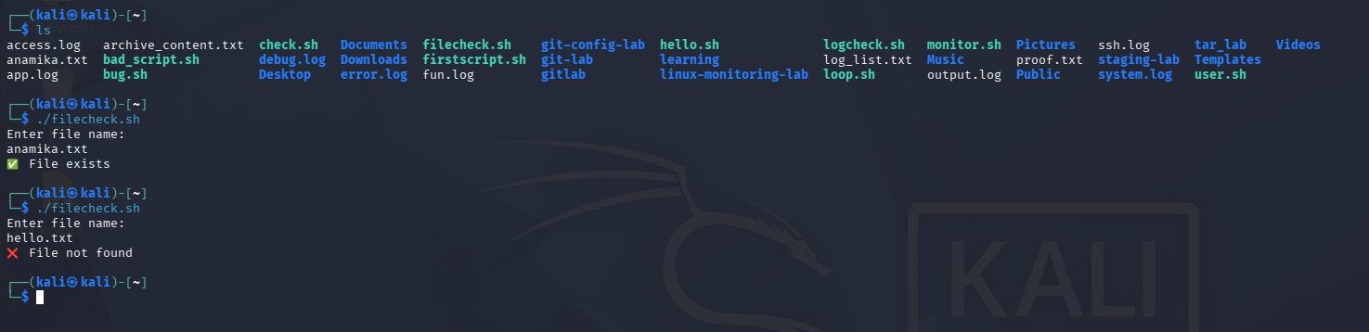

🚀 Step 8: Real-world mini automation
nano logcheck.sh
Paste:
#!/bin/bash
errors=$(grep -c "ERROR" app.log)
echo "🚨 Total Errors: $errors"
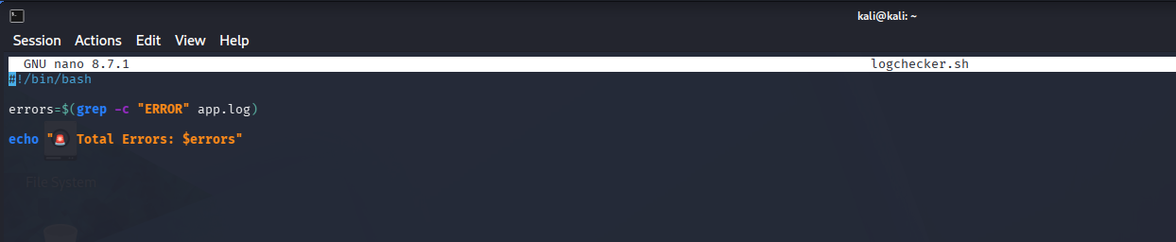
Expected Output :
There is a app.log file in my system and the content is as follows when we run the script it gives the proper output.
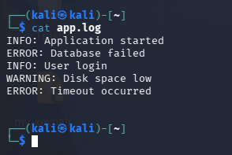
Checked for Error:
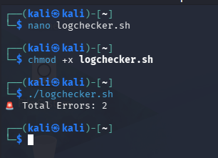
Let’s amend our script for INFO
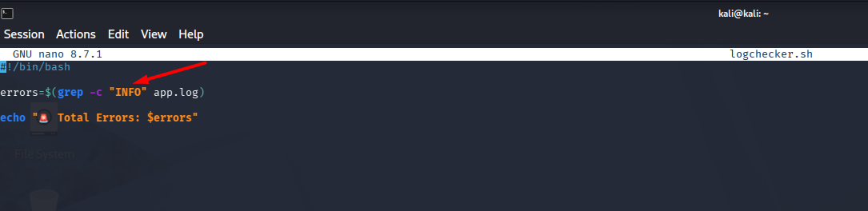
Output :
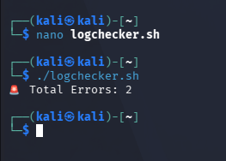

🧠 What you learned
✅ Variables
✅ Input (read)
✅ Conditions (if)
✅ Loops (for)
✅ File checks
✅ Basic automation

🎤 Interview-ready answer
“I’ve practiced shell scripting basics including variables, loops, conditions, file handling, and simple automation tasks like log monitoring.”

💡 Simple learning formula
Input → Logic → Output → Automation

🔥 Mini Challenge
👉 Modify script to:
- Ask favorite tool
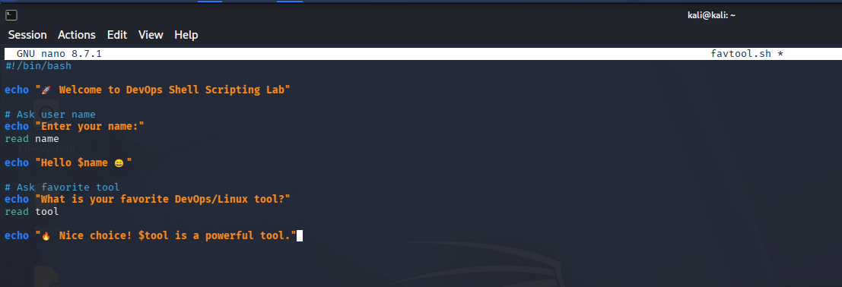
Output :
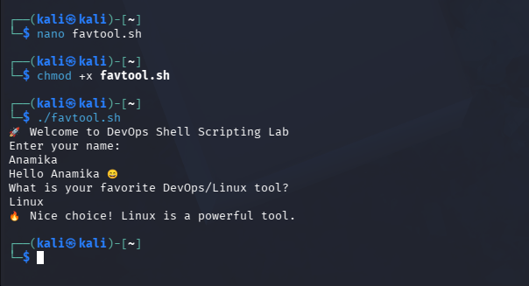
- Print motivational message
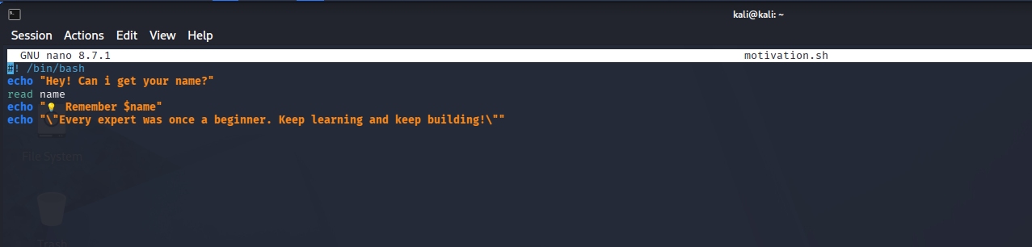
Output:
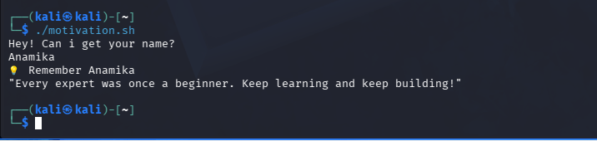
- Check 2 files
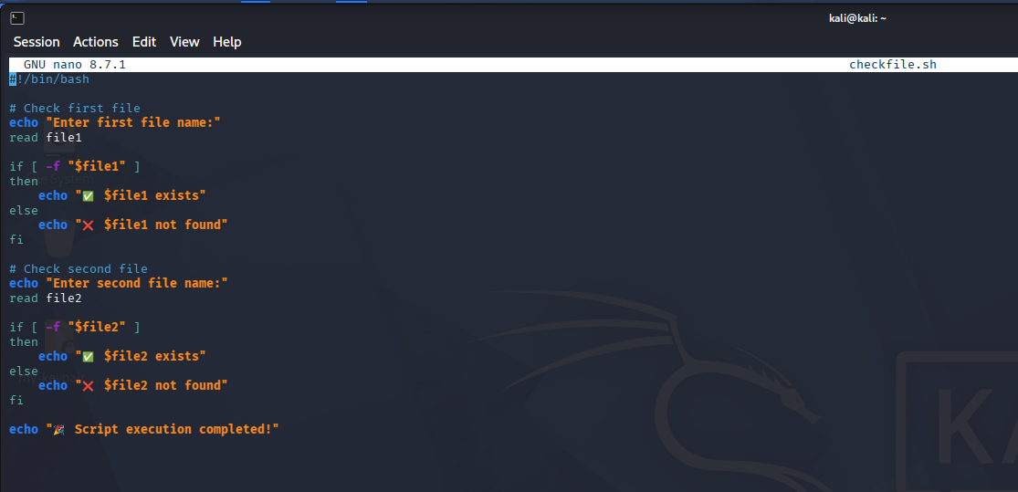
Output:
